Siddalingappa. P
House No 42/B, 2nd Floor, 1st Main, 1st Cross, Subramanyapura Post, Muneshwar Nagar, PadmanabhaNagar Bangalore - 560061
Mob: +919741088143 E-mail: siddusajjan06@gmail.com
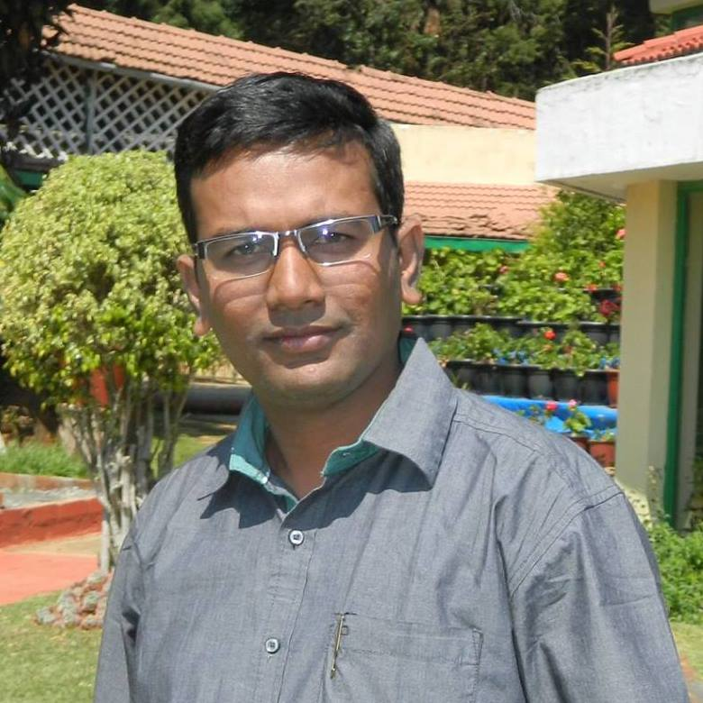

(M.B.A in Marketing and 5 years of Experience in Channel Sales Distribution & Online Sales)

SALES & MARKETING
CAREER OBJECTIVE

Seeking Sales / Marketing Manager position with especially Fast Moving product Companies, where I can maximize my knowledge, Expertise and skills that can impact corporate profits and productivity.
Focused sales professional offering more than 5 years of experience to the organization with same industry.

Seeking a challenging position, using my extensive sales and marketing background with high level income potential and finally want to become one of valuable asset for the company.

PROFESSIONAL EXPERIENCE

- (MRF Groups) Funskool India Ltd Feb-2013 TO Present

- Senior Sales Officer from Feb’13 to Mar’15 (MRF Groups) Funskool India Ltd.

ROLES & RESPONSIBILITIES

- Working as a Senior Sales Officer in Bangalore,
- Handling sales Team (2 Members in a Team)
- Motivating sales team to achieve the target.
- Handling 100 Retailers & 1 Distributor in Bangalore.
- Achieving Monthly target aggressively.

- Sales Executive From Apr’15 to Present. (MRF Groups) Funskool India Ltd.

ROLES & RESPONSIBILITIES (INCLUDING ONLINE)

- Working as a Sales Executive in Bangalore,
- Handling sales Team (4 Members in a Team)
- Motivating sales team to achieve the target.
- Handling 168 Retailers & 2 Distributors in Bangalore. (20 Online Retailers)
- Margin checking the sites everyday in (Flipkart, Snapdeal, Amazon &PayTm)
- Identifying new and potential clients every week.
- Handling Distributors (Channel Sales Distribution)
- Giving innovative ideas to TSI’s for increasing total sales in a month Like schemes Etc!!
- HANDLING ALL ONLINE RETAILERS BANGLORE

SELECTED ACCOMPLISHMENTS/ JOB DESCRIPTION

- Coordinating with the implementation and development team to ensure client satisfaction. Implementing marketing plans.
- Ensuring product delivery at right time at a right place.
- To achieve Sales targets directly, through distributors and Sales Personnel of the distributor.
- To execute the distribution plan of the territory.
- To maintain and nurture good business relations with distributors and retail trade partners.
- To forecast Sales and set targets per distributor.
- To accompany distributor Sales personnel for order booking on rotational basis (2 weeks / month) on a pre-determined cycle.
- To investigate and monitor retail outlets contribution per distributor in order to achieve the required outlet share and retail objectives.
- To establish stock norms with distributors per market and ensure stocking levels.
- To provide product knowledge and on-the-job training to distributor Sales personnel.
- To provide monthly report on each distributor in the territory.
- To provide market information and feedback on competitor schemes / offerings and product quality and reliability.
- To ensure product visibility on shop shelves.

ACHIEVEMENTS & AWARDS

- In the year of 2013-2014, I was in Elite group and Ranking No 8th. I got award from Vice President.
- In the year of 2014-2015, I was in Elite group. Top 5th got award from Senior Vice President.
Volume Of Business

- I have achieved 2013-14 Rs 330 Lacks V/s 280 Lacks
- I have achieved 2014-15 Rs 445 Lacks V/s 415 Lacks
- I have a record of achieving every month Primary and secondary target equally.
- I have got promoted as SALES EXECUTIVE from Senior Sales Officer (April-2015)

- Mitashi Edutainment Pvt Ltd From Oct-2011 TO Feb-2013

Mitashi is leader in TV video game industry in the country & one of the fastest growing Brands in the Consumer Electronics segment. With relentless commitment to quality, consistent dedication to customer satisfaction and unparalleled standards of service, Mitashi is recognized for premium quality & great value for money.

With Brand Name such as Game-in, Play smart & Skykidz Mitashi has established itself as a value leader across its various product categories of Audio/Visual Entertainment products — TV games‚ Educational games & Educational laptops.

Today Mitashi has the footprints across all major towns and cities of India with 20,000 Distributors & Dealers Network, presence in all major retails formats such as TATA CROMA, Reliance Retails, Adishwar Electro world etc & 33 service centers across India.

At Mitashi we are committed to ensure that both products & service add new dimension of enjoyments & make difference to people’s lifestyle.

- Territory Executive from Oct-2011 to Mar-2012 MITASHI Edutainment PVT LTD.

- Handling 105 Retailers & 1 Distributor in Bangalore.
- Business is Rs 1.20 Lakhs/Annum
- Achieving Monthly target sales value
- Identifying new and potential clients.
- Giving innovative ideas for increasing total sales.
- Work Profile is Completely Channel Sales.

- Territory Manager from April-2012 to Jan-2013 MITASHI Edutainment PVT LTD

ROLES & RESPONSIBILITIES

- Working as a Territory Manager in KARNATAKA.
- Karnataka Volume is Rs 1.8 Cr/Annum
- Handling 175 Retailers & 2 Distributors in Bangalore.
- Achieving Monthly target oriented sales value
- Identifying new and potential clients.
- Handling Distributors (Channel Sales Distribution)

- Sales Officer From June-2010 to Sep-2011 Zapak Digital Entertainment Ltd

- Handled 65 Retailers & 1 Distributor in Bangalore.
- Volume of Business is RS 35 Lakhs/Annum
- Achieving Monthly target sales value
- Identifying new and potential clients.
- Giving innovative ideas for increasing total sales.
- Work Profile is Completely Channel Sales.

Companies & Experiences:
- Zapak Digital Entertainment Ltd:
    - June 2010 to Sep-2011 as SALES OFFICER
- Mitashi Edutainment Pvt Ltd :
    - Oct-2011 to March-2012 as Territory Executive.
    - April-2012 to Jan-2013 as Territory Manager.
- Funskool India Ltd:
    - Feb-2013 to March-2015 as Senior Sales Officer
    - April-2015 to Present as Sales Executive

EDUCATION DETAILS

Academics | Year of passing | Specialization | University | Percentage.
M.B.A. | JUNE – 2010 | MARKETING. | BANGALORE. | 65.45%
B.B.M. | JUNE – 2008 | MARKETING. | GULBARGA. | 60.35%
P.U.C. | MAY – 2005 | SCIENCE | PU BOARD. | 44.46%
S.S.L.C. | MAY – 2002 | MATHTS, SCIENCE, SOCIOL SCIENCE. | KARNTAKA SEC EDU BOARD | 54.88%

PERSONAL PROFILE

Father Name : Late Pampapathi Sajjan
Date of Birth : 5thJune1986
Marital Status : Married
Language Known : English, Hindi. Kannada & Telugu.

DECLARATION

I am confident of my ability to work in a team and I hereby declare that the information furnished above is true to the best of my knowledge.

Date: 04-09-2015
Place: Bangalore. (Siddalingappa)

